The History of Mt. Zion African Methodist Episcopal (AME) Church, Devon,

Originally: New Centreville AME Church
Listed on The National Register of Historic Places

Full Version

“God Our Father, Christ Our Redeemer,
the Holy Spirit Our Comforter, Humankind Our Family.”

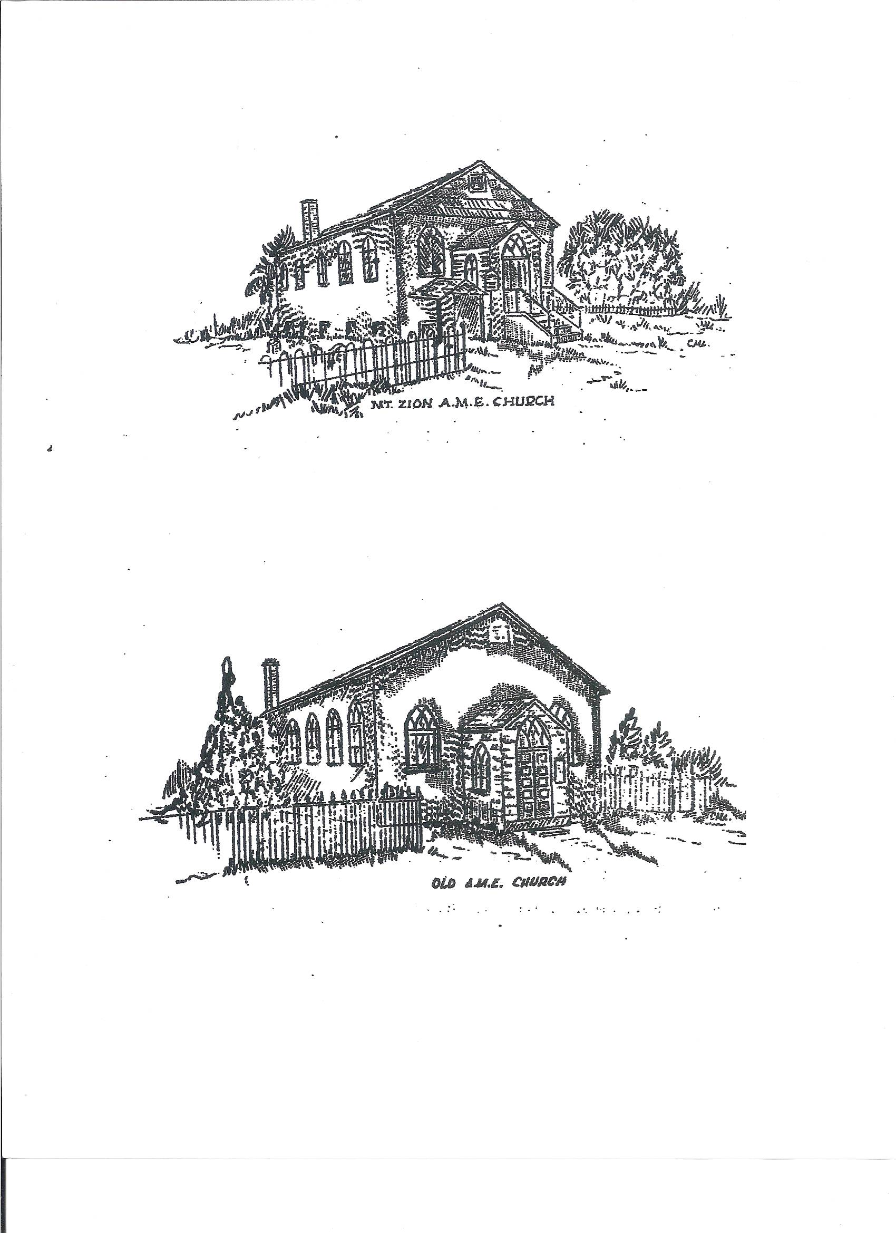
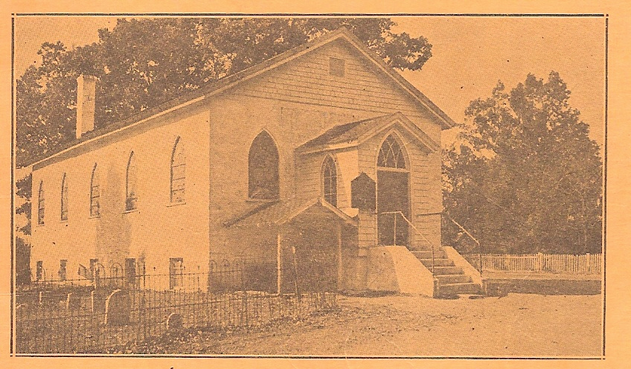

A - African meaning the church was organized by people of African descent
and heritage. It does not mean that the church was founded in Africa, or that
it was for persons of African descent only;
M - Methodist meaning members of the family of Methodist;
E - Episcopal designating the form of government in which the chief
executive officers are Bishops;
Church - meaning an organization of Christian believers who observe
the same rites and acknowledge the same ecclesiastical authority.

The original house of worship, Devon, Pennsylvania before 1936 and 1939

Mt. Zion AME Church is the first recorded African-American congregation of any denomination, and the oldest and continuous African Methodist Episcopal Church on the entire Main Line. The Main Line is about a 15 mile stretch of communities west of Philadelphia between Overbrook and Paoli along Route 30.

Also, it has the honor of being listed on the distinguished National Register of Historic Places on
January 27, 2015: Mt. Zion is the first and only African-American church and cemetery in Tredyffrin Township and is one of 313 listings in Chester County. “Of the over 3,000 listed individual properties and historic districts in Pennsylvania, there are at least 24 with a definite African-American connection.” (PA State Historic Preservation Office.) Mt. Zion is one of the “at least 24.” Read more on page 10.

In the year 1849 or 1850 a group of faithful workers saw the necessity of a church in and around Centreville (also spelled Centerville, formerly Walkerville or Walkertown, later called New Centreville, now known as Devon). Beginning with cottage prayer meetings, the interest of growing an organization developed in the home of Henry and Sarah Roach of Hammer Hollow (a section of Devon). Nelson Hughes was a local preacher and conducted the services. They also held services in a vacated shop across the road from the site of their own future church building. The church was completed and still stands at its original location, on the corner of Berwyn-Baptist and Fairfield Roads.

The deed states: This indenture made the thirtieth day of January in the year of our Lord one thousand eight hundred fifty-six AD between Jonathan Lewis of Tredyffrin Township, Chester County and the State of Pennsylvania of the one part, and Henry Roach, Moses Crooks and Lewis Draper. Trustees in trust for the use and purposes hereinafter mentioned all of the County of Chester and State of Pennsylvania aforesaid of the other part. (A month later, a second deed was filed on behalf of Lewis’s wife Mary Ann, since the two parties had overlooked her when the earlier deed was filed.) Purchased for the sum of $50.00. Purpose: To erect a place of worship for the members of the African Methodist Episcopal Church.

It is noted that the seller, Jonathan (T.) Lewis was a member of the Wilberforce Anti-Slavery Society, founded in the nearby Baptist Church in the Great Valley in January 1837 by its pastor, Rev. Leonard Fletcher and residents of Berwyn and Wayne.

Among the faithful founders of Mt. Zion were: Henry and Sarah Roach, Moses Crooks, Lewis Draper, Hector Mullen and his sister Julia Ann Mullen Laws, Jane Crumbles, Nelson and Liza Hughes, Simon and Binie Tittle, Mary Ann McClane, James and Elizabeth Hitch, Eric Brown, Benjamin Ross, the Caesar Van Leers, Abraham Coursey, Johnsons, Gloscoms, Dills, Boggs, Hipples, and Henry and Sarah Jacobs.

Some of the church members lived in the small cluster of homes at the intersection of Berwyn Baptist and Fairfield Roads. The area was originally known as Churchtown, derived from our church’s location. Sometime after 1864, it was later known as Quigleytown or Quigleyville, and also called Devon Hill.

On the Main Line, Mt. Zion AME has been the only African American church of any denomination with a cemetery. One of the last persons buried here was Mollie Hopkins in 1952. Among those at rest are church founders, members and family of members of the church. There are 19 named & one unknown Civil War Veterans interred in one of the larger groups of Colored Troops buried in a church cemetery in the area. In 1894, it was reported in the Daily Local newspaper that at the annual memorial service at our cemetery, “Fully 1,000 persons were present to witness this memorial service

Our church was part of several circuits at various times. Two of the earliest known were the Centreville Circuit which was comprised of Phoenixville, Centreville and Valley Hill (East Whiteland Township), and the Oxford Circuits. Other circuits included Norristown, Malvern, West Chester and Bryn Mawr, all in Pennsylvania.

Rev. Nelson Hughes (1849 or 1850-Unknown). Church building began under his pastorage. The cornerstone was laid in 1861. The work ceased during the Civil War when many men left to serve in the Union Army and the Navy. He served as an US Colored Troop (USCT) and is buried in our cemetery.

September, 1862, the church, New Centreville AME Church, was dedicated by Rev. Jeremiah Burleigh. The bishop who was to dedicate did not arrive. The membership then was 11.

Rev. William R. Norris (1865-1866?) increased membership and married several couples.

Research for our pastors continues for previous and ensuing years between 1850 and 1872.

Rev. Charles Wesley Boardley (1872-1880). After the Civil War, church building work continued under his pastorage.

Rev. William H. Davis (1880-1882) completed the first church. The Historic Church still stands on its original location, on the corner of Berwyn-Baptist and Fairfield Roads. Occasional services and events are held there.

The following pastors were: Reverends Burr W. Bolton (1882-1886), Jeremiah B. Hill (1886-1888), and
John J. Campbell (1888-1890).

Rev. Noah D. Temple (1890-1892) opened the church on August 3, 1890, after being closed for six weeks for renovations and improvements. It looked like a new edifice. Also, the church held its 28th anniversary on October 26, 1890. The membership was 84.

Other pastors were: Carleton M. Tanner (1893-1894 and son of Bishop Benjamin T. Tanner), George R. Miller (1894-1895), Jonathan W. Taylor (1895-1896) and Benjamin F. Lloyd (1897-1898).

50 to 100 Years

Rev. I.H.W. West (1898-1901) raised money to rebuild the church because it had become too small to hold its growing membership.

Rev. Elijah Byrd (1901-1903). During his pastorate, the church was transferred from the Lancaster District Conference to the Philadelphia District Conference within the First Episcopal District (oldest Episcopal District) in African Methodism. On September 23, 1901, the church name was changed from New Centreville AME Church to Mt. Zion AME Church, Devon.

He tore out and extended the church building toward the east, changed the entrance from Berwyn-Baptist Road to the present side, facing Fairfield Road (probably because Christianity practices facing east during prayer or service for various reasons ranging from Jerusalem is in the East, Christ will return in the East, the Holy Temple will be rebuilt in the East and the sun rises in the East).

Also, Rev. Byrd fenced the graveyard. Church records show payments made for stained glass windows, carpet and a pulpit suite in November 1901.The church reopened between August and November 1901.

Rev. Charles H. Fareira served two terms, (1903-1908 and 1912-1914). During his first term, he put in a basement (completing the church, which may explain the “REBUILT 1906” on one of the datestones) and left $400.00 in the bank for the cemetery. In his second term, he raised $500 for the parsonage.

Rev. Elijah Turner C. Bruce (1908-1912) instituted the Harvest Home, fenced the cemetery and installed electric lights.

Rev. J. L. H. Watkins (1915-1916) purchased the parsonage on Walnut Avenue, Berwyn.

Rev. R. F. Wright (1916-1920) built a garage and left $400 in the bank.

Rev. William Richard Gullins, Jr. (1920-1921) carpeted the church.

Rev. W. H. Coffee (1921-1923) installed a new heater.

Rev. J. A. Thomas (1923-1926, two years and eight months) remodeled the parsonage.

Rev. Charles Shepherd (1926), who was licensed to preach in 1907 as a local elder, supplied as pastor after Rev. Thomas’ death, and reported the church to conference in full.

Rev. J. R. Johnson (1926-1932) renovated the church and paid debts in full. Through his solicitations, families of the church presented new stained glass windows in honor of their loved ones. Tredyffrin Township records show the windows circa 1922 at the cost of $22.00 each. Church records showed a payment on the windows made in early1926 under Rev. J.R. Johnson‘s pastorship.

Serving one year each: Reverends W. L. Johnson (1932-1933) and Monty W. Frazier (1933-1934).

At the end of Rev. J.R. Johnson’s term and during the terms of both Reverends William Lester Johnson and Monty W. Frazier, one of the most significant of Mt. Zion’s contributions to the community (and beyond) took place. It was a meeting place for local Black families to plan how to immediately, and then continually, respond to a policy of segregation of their public elementary school children (grades 1-8) from white children in March 1932, imposed by two separate school districts, Tredyffrin and Easttown.

March 10, 1932 - April 30, 1934 - For two years, the “School Fight” or the “Berwyn School Segregation Case” was a considerable milestone in Mt. Zion’s history. Black families fought back. With the local leadership of Primus Crosby, Harvey Tyre, Edgar R. Powell and others, the legal guidance of the Hon. Raymond Pace Alexander (1959, Judge, Common Pleas Court of Philadelphia), and the support of the local Bryn Mawr Branch of the NAACP, the Black families boycotted the elementary schools. Some children were taught in Mt. Zion’s parsonage, others were home schooled or traveled or moved to nearby areas to attend school. Some did not go to school at all. Many parents were fined or arrested and jailed for their "truant children," threatened with job loss, attended court sessions, protested and were willing to demonstrate in Philadelphia (5,000 people were expected) with their supporters to break the legal impasse maintained by the Pennsylvania’s state attorney general.

Throughout the two years, the Black families met at Mt. Zion monthly (sometimes more frequently) to strategize their battle. Many dignitaries and visitors attended, such as the leadership of the National NAACP: Walter White, Secretary, Roy Wilkins, Assistant Secretary, Dorothy Lampkin, National Board; NAACP members from New York, Oscar DePriest, the first African American elected to Congress in the 20th century, Crystal Bird Fauset, first African American woman in any state legislature, and Joseph H. Rainey, editor of the Philadelphia Tribune.

The families won when the case was settled out of court on April 30, 1934. The children went back to school the next day, although they returned to the same grades they left two years earlier. The children lost over 300 school days from their elementary school education.

Three of the significant outcomes of this very important event, known as the “School Fight” or the “Berwyn School Segregation Case” that impacted civil rights” were:
- The case assisted in the passing of the Pennsylvania Equal Rights Bill in 1935;
- The NAACP realized the importance of expanding their coalition-building, and,
⁻ The civil rights strategies used by the Black families were a “dress rehearsal” for the
modern Civil Rights movement: “a boycott, jail-ins, mass meetings, interracial cooperation, threats of
mass protests that were effective even when they did not occur, tensions between local and national
civil rights leaders, alliances with and fear of the left, and white backlash.”

Other pastors with one year of service were J. R. Reed (1934-1935) and H. L. Hughes (1935-1936).

Rev. J. Randolph Fortune (1936-1941) beautified the church auditorium and basement, parsonage and cemetery, bought five acres of ground for Camp Meetings, built the Bower, installed a new heater, re-carpeted the church, had a new roof put on the church, paid off two mortgages and paid back taxes and all debts. Under his pastorage, the original first portion of the Church History was presented in the Ninetieth Anniversary Program Booklet in 1939.

Rev. Matthew Hamlin (1941-1946) had the church and parsonage painted.

Rev. C. B. Crawford (1946-1947) had a heater put in the parsonage and the parsonage was papered.

100 to 150 Years

Rev. Samuel B. Randolph (1947-1953) had water and the lavatories installed in the church and also started painting the parsonage. The Senior Choir installed a new organ and paid for it in less than a year with Mary Anderson as their President. Rev. Randolph also instituted the "Altar Prayer".

Rev. Charles H. Carter (1953-1962) was sent to Mt. Zion on May 23, 1954. In 1955 the Usher Board purchased a new carpet for the church. The Senior Choir donated a new Communion Table and Choir Chairs. New offering plates and the pulpit lamp were presented by the Missionary Society. Stewardess Board No. 1 presented a new communion set.

During 1956 the church was painted outside, the basement renovated and oil heat, tile flooring, and public telephone were installed. A new Tithing box was installed and Hymnals presented to the Sunday School by Rose E. Harmon who served as Secretary for many years.

During 1957, cabinets were put in the kitchen, all work being done by the men of the church. Mary Anderson presented china, silver and glassware of all descriptions to the church. A men's club had also been organized.

Rev. Herman M. Satterfield’s (1962-1963) first text was as follows: "The sheep must be gathered".

A beautiful large Bible was given to the church in memory of Ida Carroll, presented by her daughter and stepson-in-law. New lights were put in the church donated by Mr. and Mrs. William Jones; they also added new oil heating system in the parsonage.

Rev. Satterfield became ill and the members tried to carry the church with different ministers, including Rev. Isaac O. Ryder, Jr, coming Sunday mornings to serve. On March 25, 1963, Rev. Satterfield passed away, leaving the church in sadness. But with the help of God, we the members of Mt. Zion, knew that we had to carry on. At this time, our Presiding Elder, Dr. John A. Alexander assigned Rev. J.W. Jenkins (several months 1963) of Philadelphia, as our pastor until conference.

Rev. S. Frank Emanuel’s (1963-1964) first text was "A man in Christ is a new Creature." The message stirred our hearts and gave us new hope, faith and inspiration, with a desire to try and do our best.

Work began on the church. The men painted the outside of the church; Mr. George Rogers who gave his service willingly, painted the basement. Iron rails for the front steps were donated by Mr. and Mrs. Leroy Johnson. The basement was cemented and tiled and new tables and chairs for the basement were donated by the Senior Usher Board with Mr. Maurice Rickards as their President. The interior of the church was painted and the full cost was donated by Mr. and Mrs. William Jones. The Pulpit chair and kneeling pad were reupholstered by Mrs. Mary Childs and Mrs. Minnie King. Mrs. Childs also donated new choir drapes. A new hot water heater was donated by Mr. Edward Jemmott and Mr. Raymond Dark.

Rev. Emanuel organized a new Young Adult Choir with Miss Carolyn Baylis as their President. The Sunbeam Choir was organized with Miss Esther Long as Supervisor. The following organizations were also established by Rev. Emanuel: Men's Chorus, Junior Usher Board, Pastors' Aides, Board of Christian Education with Mrs. V. Dessie Vause as director, and the Presidents Council.

November 1964, Rev. Emanuel left Mt. Zion.

Rev. George Reid came to Mt. Zion November 22, 1964 and only stayed for a half a year. The parsonage was renovated during this time.

Rev. Alexander L. Stephans served one year (1965-October 1966).

Rev. Leon Burnham (1966-1972). During his stay, Albert Weldon, treasurer of the building fund under supervision of the trustees, contacted and collected money for the purchase of pews and pulpit furniture and a bulletin board. Pastor's office was built by Thomas Snowden, who was assisted by Norman Childs, Jr., John Vause and Fred Washington. New floors were put in the main auditorium by the trustees. John Vause was called to preach while Rev. Burnham was with us. In 1969 and 1970 the Sunday School was reorganized by Mary Anderson.

Rev. James Winsmore Mason (1972-1973). The church received other improvements by the trustees.

A new roof and a new steeple were installed, and painting inside and was done by Roach Brothers. The basement was renovated by Fred D. Washington and the trustees.

Rev. Nathaniel L. Williams (1973-1982) became the new shepherd of our church. His appointment was a blessing. The gathering of his flock began immediately. Rev. Williams reorganized the Young Adult Choir with Richard B. Williams, Jr. as their President. The Pastor's Aide was reorganized with Esther M. Long as President.

The following organizations were introduced by Rev. Williams: Concern Club, Elizabeth Childs, President, and the Angelic Choir, Esther Long, Supervisor.

His flock began to grow. We had six Baptisms, twelve new members and one marriage. In one year's time our congregation had tripled in attendance at Sunday morning services and other affairs. This was due to the rejuvenating spirit of this good Shepherd.

A new Pew Guard was donated by Clifford E. DeBaptiste & Family. Paulette E. (Pierce) Ware donated a suggestion box.

With the help and grace of God, the love and prayers of our friends and congregation and the leadership of the Devoted Pastor, we knew that Mt. Zion Devon would continue to grow in Grace and Love.

The church grew with the following organizations: Young Adult Ushers - Host and Hostess Club with Gertrude Pierce as their supervisor, Junior Echoes, Male Chorus, Drama Club and Altar Boys with Gary Speller and Milton Vause.

A duplicating machine was purchased and operated by Essie M. Brock.

In addition to a central air conditioning system, renovations of the lower auditorium and kitchen added significantly to the comfort and convenience of the church.

The Wayside Pulpit was repaired with cinder blocks and stucco donated in Memory of William Jones by Eddie Lee Jones.

In 1979, the kitchen was remolded by Fred D. Washington, Bill Butcher, and Norman L. Childs, Jr. Rev. Williams appointed Gertrude Pierce as Head Usher. Seventy-five hymnals were donated by Lenora Johnson.

Rev. John Morgan. Dawkins, Jr. (1982-1986) immediately began to gather and know his flock. Thomas A. Jackmon, Sr., was appointed by Rev. Dawkins as Pastor Steward. Rev. Dawkins reorganized the Sunday School with Brenda Holland as Superintendent, Junior Ushers with Gertrude Pierce as Supervisor and Norma Ann Armour as Assistant Supervisor.

The following organizations were introduced by Rev. Dawkins: Finance Committee, Task Force, Central Budget, President’s Council with Laraine Speller as President, Celestial Choir, Youth Choir, and Minister of Music, Heather L. Vause.

Rev. Dawkins instituted a church office with Gertrude Pierce as secretary.

Rev. Charles E. Drummer, Sr. (1986-1992) oversaw the process of building a new church. On July 8, 1989, Mt. Zion AME Church broke ground for the new building (with the church cemetery lying between the original church building “Old Mt. Zion” and the new church). The groundbreaking service was led by Bishop Frank Curtis Cummings, Presiding Prelate and Rev. Charles E. Drummer, Jr., Pastor. Other pastors who attended the groundbreaking were Rev. Richard R. Stokes, Rev. Luther McNair, Rev. S. W. Daggett, Rev. M. D. Wayns, Jr., Rev. Carrie Nobles, Rev. W. H. Carr, Rev. Johnnie Vause and Rev. Dr. Theophilus E. Harper.

October 1989, Thomas A. Jackmon, Sr. preached his trial sermon at Mt. Zion.

In 1990 Mt. Zion AME Church was rebuilt with Frank Curtis Cummings D.D., LL.D., Presiding Bishop, Theophilus E. Harper, D.D., Presiding Elder, and Charles E. Drummer, Jr., D.D. D.H., Pastor. The stewards were as follows: Joseph T. Bell, Margaret E. Bell, Thomas A. Jackmon, Sr., Mildred McKim, Gertrude Pierce, Laraine A. Speller, Floretta D. Washington, Monroe W. Weldon, M. Pandora Williams. The trustees were as follows: Norman L. Childs, Jr., Essie M Brock, Estelle K. Burton, Pauline Dennis, Eddie L. Jones, David Mills, George A. Rogers, John T. Tunnell, and S. Edythe Washington.

Rev. Melvin D. Wayns, Sr. (1992-1995) assumed the pastoral responsibilities of Mt. Zion AME Church. During that time, the parsonage and lower level were completed. Rev. Wayns was instrumental in establishing Mt. Zion as the site for a Chester County Head Start Center. He was also instrumental in reducing our financial obligations by seventy-five percent.

On September 27, 1993, the last service held at the “Old Mt. Zion” was the funeral service for Harvan Williams. Then, those church doors were closed.

In 1993 Rev. Thomas A. Jackmon, Sr. became a local deacon.

Rev. Jackmon started the Emily Ingram Scholarship Fund by donating his love offering. With that idea other parishioners and family of Emily Ingram worked on programs to build up the Scholarship Fund.

Rev. Calvin W. Jackson, Sr. (1995-1998) organized the CWJ Outreach Gospel Choir in December 1995. Rev. Jackson also organized a committee for Unity Day on April 28, 1996. Harry Wright and Patricia Gaines were the co-chairs. On Sunday, October 27, 1996 Mt. Zion celebrated its 147th Anniversary with Edward Gowens and Daisy Long as Co-Chairs.

November 8, 1996 Mt. Zion AME Church honored Essie Brock with an Appreciation Banquet. The guest speaker was The Honorable Judge A. Leon Higginbotham, Jr.

January 1997 Marilyn Tunnell preached her trial sermon at Mt. Zion.

April 1997 Mt. Zion AME Church became one of the sites for Kumon Learning Center.

May 1997 Marilyn Tunnell became a licensed Evangelist.

May 2, 1998 Mt. Zion AME Church honored Margaret Bell, Eddie Lee Jones (deceased prior to the banquet), David Mills and Floretta Washington.

May 9, 1998 by the Grace of God, Mt. Zion AME Church relinquished our mortgage debt by the gracious and significant donation of $5,756.00 from Laraine Speller. Rev Calvin W. Jackson, Sr. - Pastor, Rev. Dr. Richard F. Norris - Worship Leader, and Presiding Prelate, First Episcopal District of the African Methodist Episcopal Church Bishop Philip R. Cousin - Sermon. Bishop Cousin's topic was “Blind Faith.” The Mortgage Burning Service was dedicated in memory of Bertha E. Jackmon.

150 Years On

Rev. Gerald H. Hesson (Dec. 1998-2001) appointed by Bishop Philip R. Cousin, Sr., provided leadership in the areas of fiscal management, stewardship and spiritual growth. As the result of his leadership and that of the Steward and Trustee Boards, an air conditioning system was installed for the church and parsonage, and a renovation of the parsonage was initiated. The class leader system was revitalized.

During October 18-22, 1999, Mt. Zion celebrated its 150th Church Anniversary. Wendy Brown and John Tunnell were the co-chairpersons of this celebration which featured a Youth Service Worship, a historical program featuring the early days on Zion Hill, a Revival featuring Rev. Nathaniel Williams as the revivalist, and a banquet at the Westover Country Club. Bishop Philip R. Cousin, Sr. was the featured speaker at the 150th Anniversary Banquet. Dr. M. Joan Cousin, Episcopal Supervisor, received special recognition during this Banquet.

Also, honored in recognition of dedicated service and stewardship to Mt. Zion were Nancy Jemmott, Essie Brock, Gertrude Pierce, Estelle Burton, Daisy Long, George Rodgers and Andrew Long. Other honored guests included Rev. Michael Thomas, the Master of Ceremonies, Rev. George T. Sims, The Presiding Elder of the West District, Martha Pinckney and Rebecca Brown provided the music for the program. Rev. Dr. Melvin D. Wayns, Jr., Rev. George Beachum and Robert Rickards were also participants. Rev. Hesson offered the benediction to conclude the Banquet celebration.

Rev. Nathaniel L. Williams (Second Term 2001-2004) assumed the pastoral responsibilities.

Rev. Marilyn Tunnell became a Local Elder in May 2002 at the Philadelphia Annual Conference.

On March 29, 2003 Stacey Jones Anderson preached her trial sermon.

Rev. Nathaniel L. Williams retired from Mt. Zion AME Church and the Philadelphia Annual Conference on Sunday, May 23, 2004.

Rev. Larry Thompson (2004-2007) was appointed by Bishop Zedekiah Lazett Grady.

On June 19, 2004, Mt. Zion gave Rev. Nathaniel Williams a Retirement Banquet. Rev. Williams pastored Mt. Zion for a combined period of thirteen years. Laraine Speller and the Stewards of Mt. Zion co-chaired the Banquet. Rev. Thomas A. Jackmon was the worship leader. The Rt. Reverend Bishop Richard Franklin Norris, Presiding Prelate of the Fourteenth Episcopal District was the Speaker. Other participants on the program were Martha Pickney, Sanctuary Choir of Mt. Zion AME Church, Rev. Gerald Hesson, Lic. Stacey Jones Anderson, Rev. Larry Thompson, Rev. Ellis Washington, Rev. Marilyn Tunnell, Robert Rickards, Dexter Johnson, Rev. Joseph D. Patterson, Sr., Presiding Elder, Rev. Dr. Jeffrey Leath, Sheila Booker, Kelly Murray, and the Bertha E. Jackmon Singers.

Rev. Gerald. DeVan (2007-2009) served for two years.

Rev. April M. Martin (July 2009 to Present). We were truly blessed to have Rev. April M. Martin, our first female pastor, come to us in July 2009 and be her first pastorage. She has inspired us with her great vision and energy to accomplish many outstanding programs and events. Since her arrival, she has replaced the sidewalks; landscaped the front grounds; re-instituted the Lay Organization with Juliet Jeter as President and Church School with Rev. Marilyn Tunnell as Superintendent, and assigned the position of Church Historian with Bertha L. Jackmon.

On May 8, 2010, she hosted the “Commemoration of the School Segregation Fight in Tredyffrin and Easttown Townships in Chester County, Pa, 1932-1934” (aka “The Berwyn Case”) in honor of the local African American families (some of whom were church members) who stood-up for their children and regularly met at our church. During this program, Pennsylvania State Senator Andrew E. Dinniman presented the church with a Citation on behalf of the Pennsylvania State Senate to honor the Commemoration.

On September 19, 2010 our 161st Church Anniversary featured Rev. Dr. Charles H. Lett, Sr., Presiding Elder, West District, and Bishop Richard Franklin Norris, Presiding Prelate First Episcopal District as our morning and afternoon Guest Preachers, respectively.

Also, Rev. Martin opened the doors of the original church building, “Old Mt. Zion”, after being closed for worship service for 18 years. For the month of August 2011, four Thursday evening worship services in the series “Pentecost Fire” had fallen on the Mount of Zion, God’s Holy Mountain.

Rev. Martin supported the first “Café Friday” in which dinners were served in the small Fellowship Hall (“Café”) on the seven Fridays of Lenten Season 2011. Under Rev. Martin’s leadership, the following activities began: an annual Veteran’s Day Program; “Morning Manna“ before Sunday Service, “Opening the Windows of Heaven Prayer Line,” “Reading for Righteousness Sake,” “Youth Sensational Summer Adventure” with the Vacation Bible School, “Alive” with herself, Rev. Willie Mae Stewart and Rev. Marilyn Tunnell walking the highways and byways spreading the good news of the Gospel; and formation of The Mt. Zion Upper Main Line Community Choir which focused on evangelism through the singing of the songs of Zion.

Furthermore, on March 8, 2012, Rev Martin established the Mt. Zion Historical and Cultural Educational Community Center and Sepulcher Board for the oversight, restoration & preservation and activities of “Old Mt. Zion” and its plans for it as a museum, community use, an educational center, such as weddings, meetings, classes, etc. Our Capital Campaign began on June 23, 2012 with a semi-formal dinner and guests were able to visit the “Old Church.”

Spring 2012, the church honored our seniors age 80 and above with a banquet. They were V. Dessie Vause, Isaac Dennis, Juanita Smith, Estelle Burton, Daisy Long, Harry Wright, Pandora Williams and George Rogers.

September 22, 2012. Another milestone for Mt. Zion was being the second church and cemetery featured in the 10-year history of the Tredyffrin Historic Preservation Trust’s (THPT) Annual Historic House Tour. The THPT is a local organization that preserves and protects historic and cultural resources in the township.

Under Pastor Martin’s watch, major damage was sustained in the new church as a result of unusual icy winter weather early in 2014 when the water pipes burst. Along with outpouring from a neighboring church and other supporters, we were able to install new carpeting in the offices and new restroom vanity on the first floor, new kitchen cabinets, refrigerator and freezer in the lower level, a new heater/air-conditioning system, electrical system, lights, some new walls and more.

Other than Graveside Salutes during our Veterans Day Ceremonies in 2009 and 2010, Mt. Zion was excited to learn of some new information about our cemetery in May 2013. Our 19th named Civil War US. Colored Troop, Sgt. Isaac “Ike” Hall, 32nd Regiment, Company K, was identified as being interred there by his great-great-granddaughter, Dianne Cross, who contacted us. She and Mt. Zion filed a claim for a free Civil War Headstone from the Federal Veterans Affairs Department, and it was installed in the cemetery September 2014 (First headstone in our cemetery in almost 60 years!). The Memorial Program and Graveside Salute, “A Slave to A Soldier to A Free Man: Commemoration of the Life of Sgt. Isaac Hall, Civil War Veteran” at Mt. Zion, Devon, Pa., October 4, 2014. will be

The Gravesite Project is another exciting and long-awaited project that started in Mid-June 2014. Mt. Zion, in conjunction with Eugene Hough of the Saving Hallowed Ground Program, based in Wayne, Pa, started the process to determine as many sunken stones, headstones and internment sites as possible. Many steps will be involved, including raising funds. A future ongoing program will be an outreach to descendants and friends of those interred at Mt. Zion.

On September 6, 2014, Mt. Zion celebrated its 165th Anniversary. Guest Preacher was Rev. Dr. Charles H. Lett, Sr. Presiding Elder West Mainline District First Episcopal District of the African Methodist Episcopal Church.

On January 27, 2015, Mt. Zion AME Church received the much sought after status of being officially listed on the National Register of Historic Places (NRHP). The Historic Church and Cemetery were included on the NRHP maintained by the National Park Service, a selective list of the most significant places or events in local, state and national history. The NRHP is the official list of the Nation's historic places worthy of preservation. Authorized by the National Historic Preservation Act of 1966, the National Park Service's National Register of Historic Places is part of a national program to coordinate and support public and private efforts to identify, evaluate, and protect America's historic and archeological resources.

The Pennsylvania Historic Preservation Office (PHPO, formerly the Bureau for Historic Preservation) stated that Mt. Zion Church met the Events criteria of significance of for Ethnic Heritage/Black and Social History: “Locally significant for its association with the African-American community’s battle against school segregation in Tredyffrin and Easttown Townships, Chester County.” Mt. Zion’s association with school segregation during 1932 - 1934, and its impact on the community’s local and state history, formed the basis for the National Register of Historic Places application.

To achieve the goal of being listed on the National Register of Historic Places is a testimony and a “dream come true” of and for all those who made previous efforts over many decades. The nation and beyond now know about our role in education civil rights (22 years before Brown vs. Board of Education) and the other great contributions made to the community by. Mt. Zion AME Church, Devon, Pa.

Since 2015, Mt. Zion has hosted the Annual Martin Luther King Day of Service events, featuring Ecumenical Worship Service on Saturday, Church Service on Sunday and the Day of Service on the Holiday (2017 Day of Service was held at Saint Luke Evangelical Lutheran Church nearby). These activities are sponsored by the Upper Mainline Ministerium in conjunction with State Rep. Warren Kampf. The Ministerium is a gathering of Christian, Jewish and Muslim congregations in the area.

On June 14, 2015, our Flag Day Celebration was listed in the 2015 Town Tours & Village Walks, Brochure. It is an annual series of tours throughout historic areas in Chester County.

In October, 2017, our large Fellowship Hall was updated including new tile floors, painted walls and window dressings, ready and open for public use.

We've come this far by Faith, and with God's help we'll see it through.

A Special thank you to Nancy Jemmott, Past Church Secretary, for her contribution and knowledge of the history of Mt. Zion AME Church, Devon.

Submitted by

Bertha L. Jackmon, Church Historian

Mt. Zion AME Church
380 N. Fairfield Road
Devon, PA 19333

610-647-5835

www.historicmtziondevon.org

historicmtziondevon@gmail.com

Rev. April M. Martin, Pastor
484-354-8239

Updated March 2017

