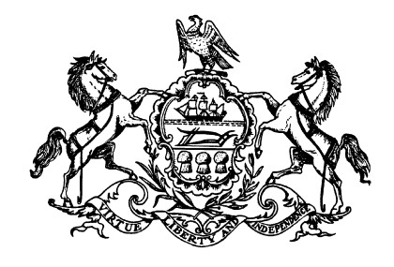
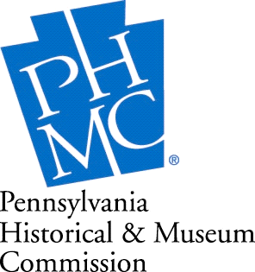

Commonwealth of Pennsylvania Nancy Moses, Chair
Tom Wolf, Governor Andrea Lowery, Executive Director

Saturday, November 21, 2020, 2:00 PM

The Pennsylvania Historical and Museum Commission

And

Mt. Zion African Methodist Episcopal (AME) Church, Devon

Present

The Dedication of Our Official State Historical Marker

Commemorating

The Berwyn School Fight 1932 - 1934

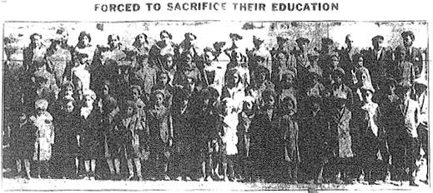
Photo Credit, The Philadelphia Tribune on 3/30/1933

Sen. Andrew E. Dinniman, Pennsylvania State Senate
Rev. April M. Martin, Pastor
Ms. Bertha L. Jackmon, Church Historian
Trustees, Stewards, Board Presidents and Members

Mt. Zion African Methodist Episcopal (AME) Church, 380 North Fairfield Road, Devon, PA 19333

www.historicmtziondevon.org
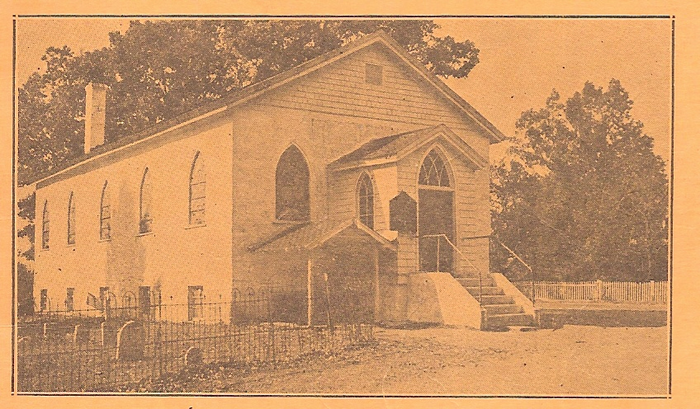
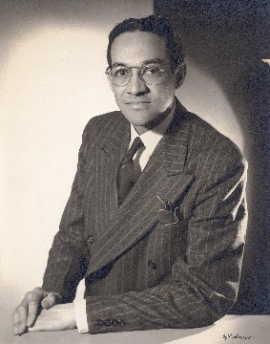

Mt. Zion AME Church, Devon 1939 Raymond Pace Alexander 1943, Attorney
Founded 1849 Berwyn School Segregation Case
Photo Credit Wikipedia

PROGRAM

Welcome Rev. April M. Martin, Pastor, Mt. Zion AME Church, Devon

Invocation Rev. Dr. Charles H. Lett, Sr., Presiding Elder, West Mainline District,
Philadelphia Annual Conference, First Episcopal District,
African Methodist Episcopal Church

Speakers Sen. Andrew E. Dinniman, Pennsylvania State Senate
Member, PA Historical and Museum Commission

Hon. Nancy Moses, Chair, PA Historical and Museum Commission

Ms. Michele Burger, President, Tredyffrin Easttown School Board

Roger Thorne, Past President, Tredyffrin Easttown Historical Society
Author, "Segregation on the Upper Main Line: The 'School Fight' of
1932-1934," printed in the Tredyffrin-Easttown Historical Society
Quarterly, Vol. 42, No. 1

Dr. Rae Alexander-Minter, Daughter of Raymond Pace Alexander, LLB and
Sadie Tanner Mossell Alexander, Ph.D., LLB

Guest Speaker Robert J. Wise, Jr., Lead Consultant for Mt. Zion's National Register
of Historic Places Application; President, Wise Preservation Planning
LLC; and Principal Senior Architectural Historian, Richard Grubb &
Associates, Inc.

Unveiling Ms. Bertha L. Jackmon, Church Historian, Mt. Zion AME Church, Devon

Acknowledgements of a few participants in the Berwyn School Fight:

- Mrs. Bessie Cunningham, Student

- Mrs. Nancy Jemmott, Teacher of Students at the Parsonage,
represented by her Niece, Rev. Marilyn Tunnell, Mt. Zion

- Mrs. Lillian Williams, Parent who offered, with an infant in her arms, to take her husband’s place in jail for their children’s truancy so he could continue to support the family. Her action triggered the ending of the jailing of the parents. Represented by her Granddaughter,
Mrs. Paulette Ware, Mt. Zion

- Mr. Oscar B. Cobb, President, Bryn Mawr (now Main Line) Branch, NAACP, represented by his Grandson, Mr. Robert “Barney” Wright, Jr.

Closing Rev. April M. Martin, Pastor, Mt. Zion AME Church, Devon

The Berwyn School Fight 1932 – 1934

Also Called “Berwyn School Segregation Case” and “Berwyn School Desegregation Case.”

Mt. Zion AME Church was a meeting place for local Black families to plan how to immediately, and then continually, respond to a policy of segregation of their public elementary school children (grades 1-8) from white children in March 1932, imposed by two separate school districts, Tredyffrin and Easttown.

March 10, 1932 - April 30, 1934: For two years, the “School Fight” was a considerable milestone in Mt. Zion’s history. Black families fought back. With the local leadership of Primus Crosby, Harvey Tyre, Edgar R. Powell and others, the legal guidance of the Hon. Raymond Pace Alexander (1959, Judge, Common Pleas Court of Philadelphia), and the support of the local Bryn Mawr Branch of the NAACP, the Black families boycotted the elementary schools. Some children were taught in Mt. Zion’s parsonage, others were home schooled or traveled or moved to nearby areas to attend school. Some did not go to school at all. Many parents were fined or arrested and jailed for their "truant children," threatened with job loss, attended court sessions, protested and were willing to demonstrate in Philadelphia (5,000 people were expected) with their supporters to break the legal impasse maintained by the Pennsylvania’s state attorney general.

Throughout the two years, the Black families met at Mt. Zion monthly (sometimes more frequently) to strategize their battle. Many dignitaries and visitors attended, such as the leadership of the National NAACP: Walter White, Secretary; Roy Wilkins, Assistant Secretary; and Dorothy Lampkin, National Board; NAACP members from New York, Oscar DePriest, the first African American elected to Congress in the 20th century, and Crystal Bird Fauset, first African American woman in any state legislature, and Joseph H. Rainey, editor of The Philadelphia Tribune.

The families won when the case was settled out of court on April 30, 1934. The children went back to school the next day, although they returned to the same grades that they left two years earlier. The children lost over 300 school days from their elementary school education.

Three of the significant outcomes of this particularly important event that impacted civil rights were:
- The case assisted in the passing of the Pennsylvania Equal Rights Bill in 1935;
- The NAACP realized the importance of expanding their coalition-building, and;
- The civil rights strategies used by the Black families were a “dress rehearsal” for the modern Civil
Rights Movement: “a boycott, jail-ins, mass meetings, interracial cooperation, threats of mass
protests that were effective even when they did not occur, tensions between local and national civil
rights leaders, alliances with and fear of the left and white backlash.”

Mt. Zion AME Church is the first recorded African American congregation of any denomination, and the oldest and continuous African Methodist Episcopal Church on the entire Main Line. The Main Line is about a 15 mile stretch of communities west of Philadelphia between Overbrook and Paoli along Route 30.

Also, Mt. Zion AME Church and Cemetery were listed on the National Register of Historic Places (NRHP) on January 27, 2015. At that time, it was, and still is the first and only African American entity (NRHP resource or listing) in Tredyffrin Township and was one of 313 listings in Chester County. “Of the over 3,000 listed individual properties and historic districts in Pennsylvania, there were at least 24 with a definite African-American connection.” (PA State Historic Preservation Office.) Mt. Zion was one of the “at least 24.”

